

**Dexcom, INC (DXCM)**

4/11/2024

Business Overview:

Dexcom, Inc. is a global leader in continuous glucose monitoring (CGM) technology, providing innovative solutions to improve the lives of people with diabetes. Founded in 1999 and headquartered in San Diego, California, Dexcom focuses on designing, manufacturing, and distributing glucose monitoring devices that help individuals manage their blood sugar levels effectively. The company's ticker symbol on the NASDAQ is DXCM. Dexcom's flagship product is its CGM system, which uses a small, wearable sensor to continuously measure glucose levels in the interstitial fluid just below the skin. This information is then transmitted wirelessly to a receiver or a smartphone app, providing real-time glucose readings and trend data. Dexcom's technology has set a new standard for diabetes management, offering greater convenience and accuracy compared to traditional fingerstick tests.

Over the years, Dexcom has continually improved its CGM systems, introducing more advanced versions such as the Dexcom G6 and the upcoming Dexcom G7. These devices offer features like alerts for high and low glucose levels, customizable thresholds, and integration with insulin pumps, allowing for automated insulin delivery. Dexcom's commitment to innovation has led to better health outcomes for people with diabetes. Dexcom's products have found a strong market presence both in the United States and internationally. The company's expansion into global markets has been supported by partnerships with healthcare providers and insurers, increasing access to CGM technology for patients around the world. Dexcom faces challenges such as regulatory hurdles and competition from other CGM manufacturers. However, the company has successfully navigated these obstacles by investing in research and development, ensuring its products meet and exceed safety and efficacy standards. This focus on quality has solidified Dexcom's reputation as a leader in the CGM industry.

Dexcom's marketing strategies emphasize the benefits of its technology, including improved glycemic control and enhanced quality of life for people with diabetes. Campaigns often feature testimonials from users and their families, showcasing the positive impact of Dexcom's products on their daily lives. Dexcom's financial success is reflected in its consistent revenue growth and solid profit margins. The company's stock has performed well over the years, making it an attractive investment for those interested in the healthcare technology sector. Despite facing competition and challenges, Dexcom's continued focus on innovation and customer satisfaction positions the company well for future growth. As CGM technology becomes more integrated into diabetes management, Dexcom is poised to play a key role in shaping the future of healthcare. Dexcom's rise to prominence in the CGM industry can be attributed to its commitment to innovation, quality, and customer satisfaction. By continuing to develop cutting-edge technology and expanding its market reach, Dexcom has established itself as a key player in improving the lives of people with diabetes worldwide.

Industry Overview and Competitive Positioning

DexCom, Inc continues to be a top medical device manufacturing company in the nation and is transforming individuals’ lives through glucose monitoring systems. The medical device manufacturing industry has been alive since about the early 1900’s but didn’t really emerge until the 1980’s due to the evolution of computers beginning in about the 1970’s. The evolution of computers changed the industry because it allowed for more trustworthy and accurate testing to be done. Due to this, more and more people started using these medical devices which then caused a spike in the industry. DXCM is a medical device manufacturing company that has risen over the years and the company's main competitors are Abbott Laboratories, Medtronic, and Roche Holding. The medical device industry is expected to grow at a rate of about 5% per year and the industry's sales are projected to be at about $800 billion by the year 2030. DXCM is supposed to beat the industry projections and grow at a rate of 18.7% over the next 6 years. Revenues from 2023 tell us that Dexcom’s competitor, Roche Holding, had the highest sales at a price of $65.3 billion. Although right now, DXCM sales aren’t as high as some of their competitors, they are trending in a great direction as they had about a 25% increase in sales from 2022 to 2023. DXCM had an EBIT margin of 16.5%, compared to their competitors they’re in the middle of the pack. The most notable expense in the industry is research and development. Companies that can manage the cost of R&D efficiently will see their EBIT margins skyrocket. The two companies that had a higher EBIT margin were Roche Holding which had an EBIT margin of 27.8% and Medtronic which had an EBIT margin of 18.5%. DXCM had a return on investment capital of 13.33% which was significantly above the industry average of 6.65%. DXCM weighted average cost of capital was 10.33% which was …. DXCM is turning a profit because they have a net margin that is above 0 which is 14.9%. Compared to their competitors in the industry, they are right in the middle of the pack as Abbott Laboratories has a net margin of 14% and Roche Holdings has a net margin of 19.6%. DXCM’s P/E ratio was 107.76 which is very high compared to the industry which is 36.4. This means that the profits they are returning are a lot smaller compared to the price of the stock. Competitors are at a more realistic P/E ratio compared to what the industry ratio is.

Valuation

I began valuing DXCM by taking factset income statement, balance sheet, and cash flow estimates. Because DXCM is still a fairly new pharma company, they are still fairly unpredictable. Therefore I thought it was necessary to break my DCF into three separate business scenarios, conservative, moderate and aggressive growth. I made these basic assumptions and altered them based on what scenario I forecasted: For sales I used the factset estimates for Sales, EBIT, and Taxes until E’29. For sales, I decided to simulate a slowed growth by multiplying the average of the previous 3 years by 90%. I agreed that DXCM will not reach a constant growth rate in the next 10 years because it has just recently started to return a profit, I believe that they are still early in their business life cycle. I estimated EBIT as the average of the previous 3 years. I believe EBIT will grow significantly because DXCM’s biggest expense is mainly research and development. I see R&D becoming less expensive as the company releases more and more drugs because research for new drugs will remain around, ultimately increasing their operating margin. I agreed that a tax rate of around 25% of sales was appropriate based on comp analysis so I took the average of the previous 5 years, taxes hovered around 25%.

For my cash flows, I used factset D&A until E’27 then, took the previous year's % increase + 1 and multiplied it by the previous year because I saw D&A growing consistently. For CapEx I took the average % of sales of the previous 5 years and multiplied it by sales. For Change in net working capital I took an average of the previous 5 years, I had trouble predicting this specifically because of the inconsistent past so this number could be subject to change.

Because I interpreted DXCM in 3 different scenarios, specific formulas were changed on different slides. Those will be disclosed below. If nothing is mentioned below, assume it is the same as described above.

**Moderate –** For my moderate example I kept the same estimate for sales as above. I estimated EBIT as the average of the previous 3 years multiplied by 1.075. I based my moderate example off of mostly factset estimates, therefore less is changed from what is explained above. I used a nominal growth rate of 2.5% based off an average of GDP growth.

**Aggressive –** I wanted to simulate the company doing very impressive, I believe that the upside to DXCM is huge based off their breakthrough diabetic drugs. I multiplied the factset estimates for sales by 120% to simulate rapid growth in sales and removed the slowed growth scenario. Then for EBIT I multiplied my factset numbers by 120% and the years after by 110%. For my aggressive model I inferred if DXCM is going to becoming overwhelmingly successful, a big part of that will be growing their EBIT margin. Because sales is much higher than the moderate model, taxes must be adjusted to hover around 25%. I multiplied the factset estimates by 1.05 and kept the rest the same. It is still rather low, closer to 21%, I decided to keep it because it is my aggressive example. For CapEx, I multiplied my factset estimates by 110% because a rapidly growing company will spend more on capital expenditures. I used a nominal growth rate of 3.5% based off a hastened average of GDP growth.

**Conservative –** I slowed growth as mentioned above by 90% and then multiplied my factset numbers by another 90% to simulate a conservative estimate for sales. For EBIT I slowed factset numbers by 90% as well but, I still multiplied my margin by 1.05 because I believe that even in a conservative example, EBIT will still grow. I decided not to change the tax rate because I want a conservative approach, it lies just around 27% average. For CapEx I slowed down the rate I believe DXCM will purchase CapEx because a company that is growing slower will spend less on CapEx. I used a nominal growth rate of 1.5% based off a slowed average of GDP growth.

**WACC Calculations –** I decided to create three different scenarios for WACC. However, some things stay the same throughout the calculations. I calculated an original cost of debt of 0.71%. I thought that was very low so I took that 0.71% and used it as the rate which short term debt costs. I used the 10 yr treasury bill at 4.25 for long term debt. Then I calculated a weighted average cost of debt by multiplying 0.71% by short term debt/total debt then adding 4.25% times long term debt/total debt.

I divided cost of equity into three different scenarios: Moderate, Boom, and Slowed. For all three I used factset’s adjusted 3yr beta of 1.18 and the 10 yr treasury bond at 4.25%. For my moderate example, I assumed a market rate of 8.3% based off an average of broker estimates. For Boom WACC I estimated the market rate at 10%, a higher estimate than the conservative 8.3%. For my slowed economic example, I estimated a 5% return from the market.

These rates have a massive impact on WACC because of how heavily equity funded DXCM is. If the market does better, cost of equity will be a lot more expensive.

Results and Investment Recommendation

**NOTE – current market price in my DCF analysis is linked with the stock price which will update every 5 minutes. Because they are linked, the calculations of over/under valued percentages might be slightly understated or overstated on this report. The DCF Model will always have the exact numbers. Market price at the time of the report is $140.11

I calculated three intrinsic values for each of my models. It became obvious early that the higher the WACC and lower the growth rate, the lower the intrinsic value of my security. Because I provided nine different scenarios, there is room for the investor to pick their scenario based off their outlook on the market and DXCM. I calculated three different scenarios for each aggressive, moderate and conservative.

**Moderate –** The first is the moderate WACC. I calculated the Intrinsic value to $83.34 over valued by 67%. This would indicate an obvious sign to sell the security. The second is the Boom WACC. I calculated the intrinsic value at $64.48 or an overvaluation of 115.9%. Therefore, the stock should be sold. The last intrinsic value calculation was for Slowed WACC. I calculated intrinsic value at $181.44, meaning the stock is undervalued by 23% so you would purchase the stock. Below is the sensitivity analysis of my moderate outlook on the company example, green indicates BUY, yellow indicates HOLD, red indicates SELL.

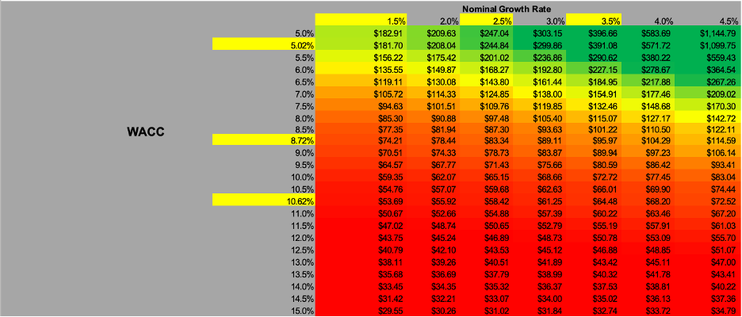

**Aggressive –** For the moderate WACC aggressive calculation I ended up with an intrinsic value of $164.89, the stock would be undervalued by 15.1%. In this scenario you would buy the stock. The Boom WACC in the aggressive example left us with an intrinsic value of $126.77 which means the stock is overvalued by 10.5%, in this case I would sell the stock. In the slowed WACC example I calculated the stock to be undervalued by 61.8% at an intrinsic value of $367.53, resulting in a purchase of the stock. Below is the sensitivity analysis of my aggressive outlook on the company example, green indicates BUY, yellow indicates HOLD, red indicates SELL.

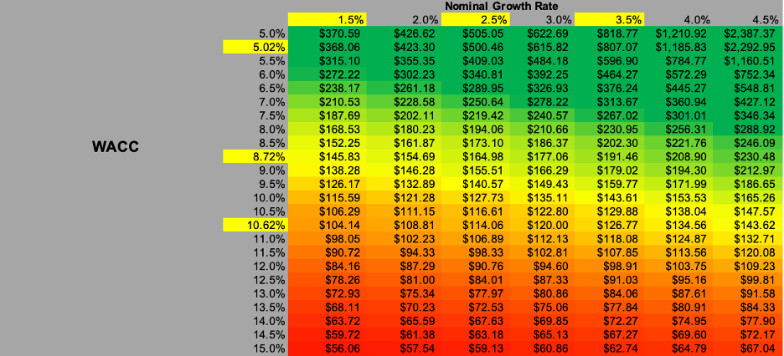

**Conservative –** For my conservative approach with moderate WACC I calculated an intrinsic value of $109.93 overvalued by 28% meaning I would be selling the stock. Then my Boom WACC example I calculated the stock to be overvalued by 66.9% at an intrinsic value of $84.28 causing a sale of the stock. Finally my last scenario, Slowed WACC with the conservative outlook leaves us with an intrinsic value of $245.37. Meaning the stock is undervalued by 42.7%, I would buy the stock. Below is the sensitivity analysis of my conservative outlook on the company example, green indicates BUY, yellow indicates HOLD, red indicates SELL.

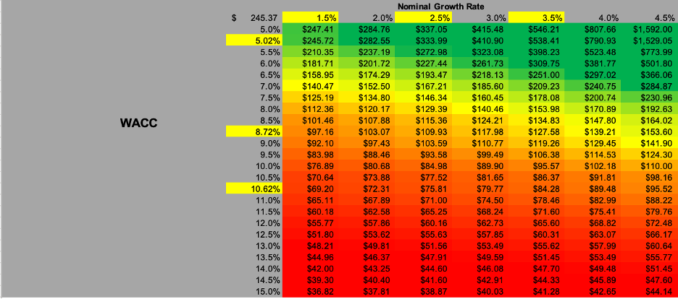

**Analysis**

I had to make many different assumptions throughout my intricate model but, WACC and Constant Growth Rate are the most important because of their value on the intrinsic value of the security. Therefore, I constructed these sensitivity analyses for each of my projections. If the company returns exceptional free cash flow, the intrinsic value still relies heavily on the WACC and Constant Growth Rate. The biggest factor in WACC is the cost of equity which is calculated by the CAPM equation that relies heavily on the expected return of the market. Therefore, the investors prediction of the market will have a massive impact on the intrinsic value. My aggressive outlook returned the highest number of “BUYS” in the sensitivity analysis and my moderate outlook showed the least. I have a different recommendation based off an investors outlook. If an investor believes that I will have a slow year for the market, I recommend buying because 3/3 of my slowed WACC examples show and undervalued WACC. On the other hand, if an investor thinks the market will have a great year, I recommend them to sell the stock, or not buy it, because 0/3 of my examples for the Boom WACC showed intrinsic value above current share price. If the investor had a moderate look on the market I would recommend selling or not buying the security because my moderate WACC returned 2/3 sells from my calculations.

A likely reason that intrinsic value is usually below the current market price is because of the high P/E ratio DXCM carries at 107. If the price was not already so high in comparison to its earnings per share, I would see much more “BUY” ratings.